Project Design Phase-II

Data flow diagrams and user stories

|  |  |
| --- | --- |
| Date | 14 October 2022 |
| Team ID | PNT2022TMID37463 |
| Project Name | Project- Signs with Smart Connectivity for Better Road Safety |
| Maximum marks | 4 marks |

**Data Flow Diagram:**

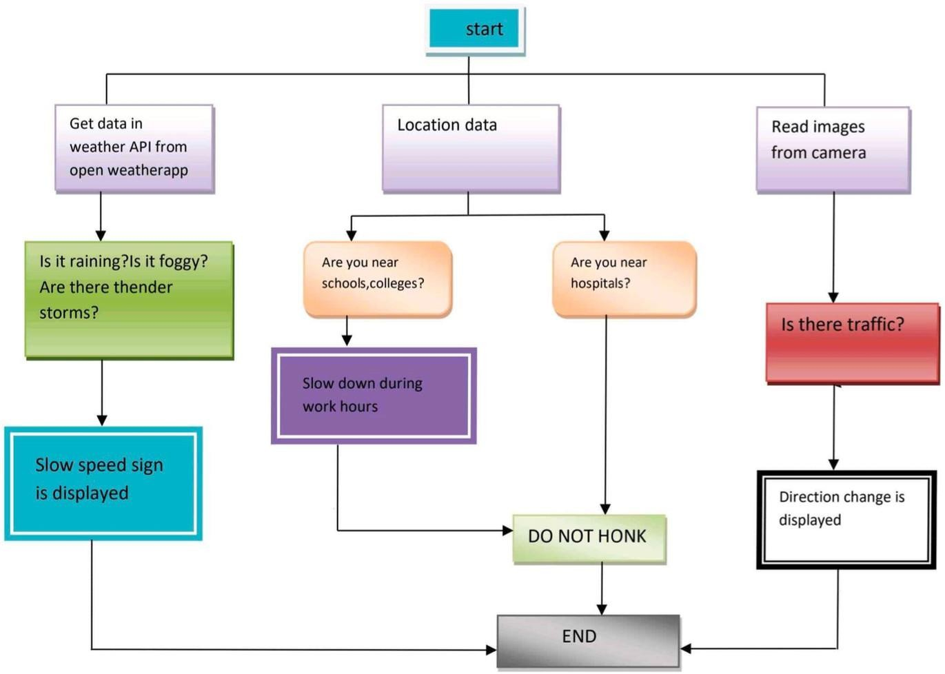

**User Stories:**

